**R Code for Examples in the book**

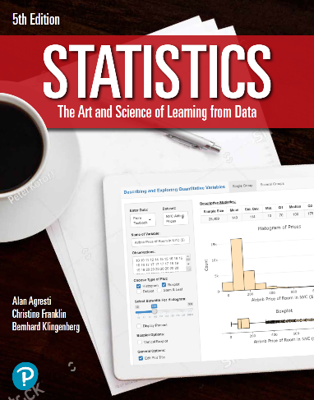

***“Statistics: The Art and Science of Learning from Data”***

**by Agresti, Franklin and Klingenberg, 5th edition**

**Chapter 11**

**Example 9: Religiosity and Gender – Standardized Residuals**

## Reading in data

mytable <- as.table(matrix(c(145, 359, 268, 275, 227, 514, 305, 235),   
 nrow = 2, byrow = TRUE,   
 dimnames = list(gender = c('female', 'male'),  
 religiosity = c('very',   
 'mod.',   
 'slightly',   
 'not'))))  
mytable # viewing the table

## religiosity  
## gender very mod. slightly not  
## female 145 359 268 275  
## male 227 514 305 235

## To perform a chi-squared test on the data

mytest <- chisq.test(mytable)

## To view the expected cell counts of the data

round(mytest$expected, 1)

## religiosity  
## gender very mod. slightly not  
## female 167.3 392.6 257.7 229.4  
## male 204.7 480.4 315.3 280.6

## To view residuals (observed - expected)

round(mytable - mytest$expected, 1)

## religiosity  
## gender very mod. slightly not  
## female -22.3 -33.6 10.3 45.6  
## male 22.3 33.6 -10.3 -45.6

## To view the standardized residuals

round(mytest$stdres, 1)

## religiosity  
## gender very mod. slightly not  
## female -2.5 -2.9 1.0 4.6  
## male 2.5 2.9 -1.0 -4.6